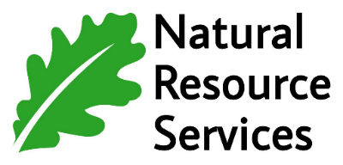
Providing ecologically sound restoration and land management services

2025 Job Announcement: Natural Resource Technician – Multiple Positions

Are you passionate about working outdoors and making a meaningful impact on the environment? This position offers an excellent opportunity to build a career in the natural resources industry. By joining the NRS team, you’ll become part of a fast-growing, dedicated company that values quality work and supports a healthy work-life balance. At NRS, your contributions are appreciated, and your hard work is rewarded. You'll also have opportunities to develop your skills and advance your career in this rewarding field.
Description: Natural Resource Services, Inc. (NRS) is seeking qualified candidates for our Natural Resource Technician positions. Technicians will assist our project managers on duties associated with prairie, woodland and wetland installations and maintenance. Projects are primarily in Minnesota with occasional work occurring in nearby states.

Responsibilities: Operate zero-turn mowers, light utility vehicles, small power equipment, and tractors with mowing, tillage, and seeding attachments. Perform general labor tasks, including hand seeding, raking, weed whipping, and targeted herbicide application as needed.
Qualifications: A strong interest in biology, ecology, forestry, botany, or natural resource management is required. Additional qualifications include mechanical skills, a valid and insurable driving record, the ability to work independently, and the ability to read and interpret project specifications and site plans.
Requirements: Willingness and ability to work outdoors in varying weather conditions and on uneven terrain. Must be able to bend, lift, and carry up to 50 lbs. Comfortable with herbicide use, along with a willingness to obtain a Minnesota Commercial Applicators License if required. Overnight stays and occasional weekend work may be necessary.
Pay Rate: Compensation dependent on qualifications and experience, ranging from $17–$20/hr. Potential opportunities to work on prevailing wage projects with pay rates commonly exceeding $45/hr.

Benefits: Potential end-of-season and annual return bonuses for seasonal employees. Other benefits may include a Simple IRA with company match, health insurance and an HSA following a 60-day waiting period.

Hours: Average 40-50 hours per week with work beginning in April and ending in October. Opportunities for longer-term or year-round employment may be available.

Location: The NRS office is located in Sauk Rapids, MN. Employees report to the office and travel to job sites in company vehicles. Depending on project locations, direct reporting to job sites may be possible.
To apply, send your resume to: Mike Evenocheck mikeevo@naturalresourceservice.com

Natural Resource Services, Inc. is an Equal Opportunity Employer
www.naturalresourceservice.com

