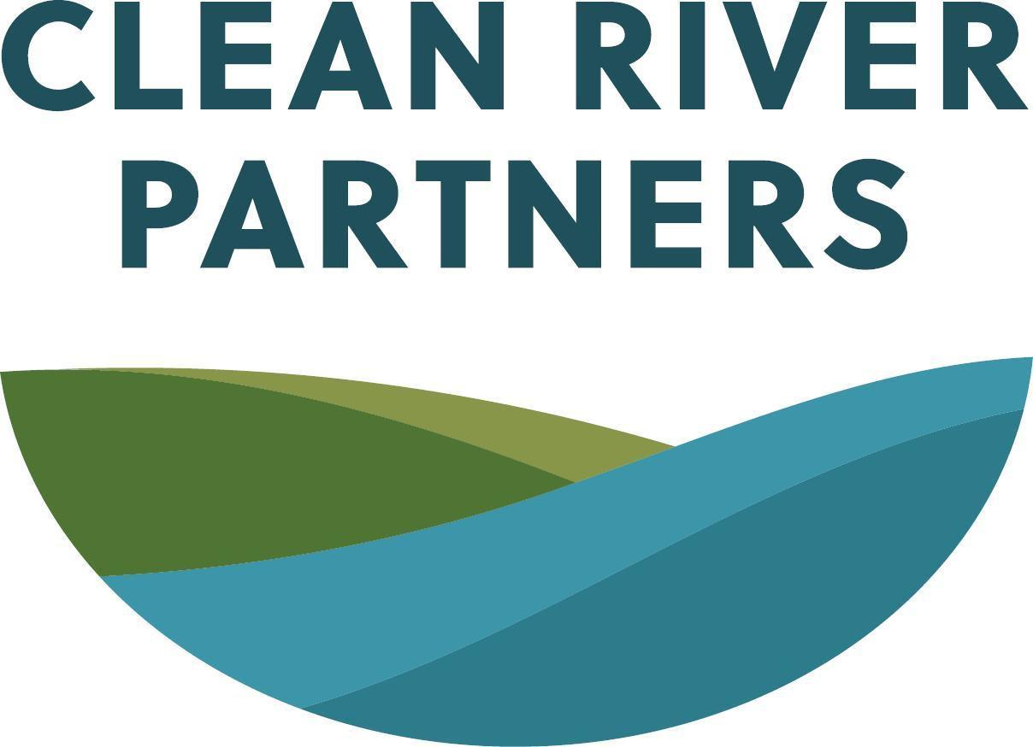
Position Description: Conservation Program Manager,

Agricultural Practices

Reports To: Executive Director
Supervises: Conservation Program Coordinator, Agricultural Practices
Status: Exempt, full-time

ABOUT CLEAN RIVER PARTNERS
Clean River Partners (CRP) is an environmental nonproﬁt based in Northﬁeld, MN. We envision a community that collaboratively creates and protects a watershed with healthy soils; drinkable groundwater; and clean, ﬁshable, and swimmable rivers, lakes, and streams. We partner with people and organizations to value, protect, and improve the Cannon River Watershed’s land and water. Our core values of building resilience, acting equitably, engaging intentionally, and inspiring hope guide all of our work. CRP is an Equal Opportunity Employer. Candidates of all backgrounds are encouraged to apply, including women, candidates of color, Indigenous candidates, LGBTQIA2S+, or candidates with non-traditional work or experience backgrounds.

POSITION DESCRIPTION
This position develops, executes, and manages Clean River Partners’ conservation agriculture work that builds the capacity of southeast Minnesota’s agricultural sector to adopt conservation agriculture practices, especially those that mitigate and/or adapt to climate change, improve water quality, and/or build soil health. This position is for someone with knowledge of the agricultural sector who is passionate about supporting systems-change efforts focused on farmer engagement, technical assistance, and, when applicable, financial incentives. This position will work closely with the Executive Director, partners, and area farmers to develop, pilot, and scale behavior-change initiatives and other programming focused on the adoption of conservation agriculture practices.

This is an exempt, full-time position with beneﬁts—potential flexibility on full-time hours to accommodate on-farm work schedules or other circumstances for well-qualified candidates. Benefits include Simple IRA matching, paid vacation and sick leave, 15 paid holidays, and a paid ofﬁce closure from December 24-January 1. The salary range for this role is $53,500 to $71,750. CRP offers a ﬂexible workplace. Most staff choose a hybrid work schedule, with all staff in the office on Tuesdays.

ESSENTIAL RESPONSIBILITIES
- Design, implement, evaluate, and continuously improve programs and projects that promote the adoption of conservation agriculture practices across the southeast Minnesota landscape.
- Develop, steward, and sustain strategic relationships with diverse landowners and farmers, as well as other conservation professionals, to advance the adoption of conservation agriculture practices and build the local agricultural sector's capacity to transition to these practices.
- Provide timely, accurate technical assistance to corn and soybean growers as they adopt conservation practices.
- Maintain, track, and report on key data related to indicators of success identiﬁed in Clean River Partners’ strategic framework and use findings to inform program improvement and future conservation strategies.
- Evaluate program activities and make recommendations to improve impacts and/or develop new programming.
- Prepare grants and other written communications, as well as public or small-group presentations, that describe program objectives, activities, and impacts.
- Track grant and contract deadlines, deliverables, and reporting requirements, including preparation of contracts, invoices, and reports.
- Develop relationships with groups underrecognized in CRP’s current collaborators, membership, and audience, including communities of color, Indigenous communities, Spanish-speaking communities, disabled communities, LGBTQIA2S+ communities, and youth.
- Participate in annual budgeting process and monitor program and project budgets.
- Participate in team meetings and represent CRP on committees.
- As needed, take on additional duties to enhance the team's work, including, but not limited to, developing documentation or improving the systems and tools used by the team.

EDUCATION, KNOWLEDGE & SKILLS
Required
- Applied experience with conservation agriculture and soil health practices such as growing cover crops, no-till farming, or perennial crops or a degree in a ﬁeld closely related to agriculture and water such as agronomy, soil science, water resources science, or agricultural education or equivalent.
- Minimum ﬁve years of progressively responsible experience in conservation agriculture or closely related program leadership roles.
- Experience collaborating and partnering with a variety of people and organizations to accomplish goals.
- Experience in managing multiple projects at the same time.
- Experience working with diverse populations and communities.
- Proficiency with common workplace technology, including Microsoft Office, Google Suite, spreadsheets, databases, and shared drives.
- Must be able to travel within the Cannon River Watershed and other locations, especially in southeast Minnesota, and provide in-person programming and technical assistance (often on-farm) when necessary.

Preferred
- Knowledge/experience with the Cannon River Watershed region and communities
- Experience in a nonproﬁt
- Experience developing and leading multi-partner initiatives
- Experience supervising others
- Advocacy or policy experience
- Systems-change experience
- Grant-writing experience
- Grant management/administration experience
- Experience with government funding programs or public contracts
- Proﬁciency in one or more non-English languages, especially Spanish, Dakota, Somali, and/or Hmong

WORKING ENVIRONMENT
This role requires a blend of public-facing and behind-the-scenes work and includes regular collaboration with internal staff and external partners. Work is primarily sedentary, though there is some movement, travel, and carrying of heavier items, such as bins of activity supplies.

Clean River Partners’ normal business hours are 8:30 AM – 5:00 PM Monday-Friday. CRP’s ofﬁce is in an ofﬁce building and in an adequately lit and climate-controlled, ADA-compliant space. Most staff choose to work a hybrid schedule; we are all in the ofﬁce on Tuesdays. This person will share an ofﬁce space with coworkers but will have a dedicated workspace and computer. This position requires meeting in various community spaces, including outdoor and on-farm spaces, for relationship-building, providing technical assistance, collecting samples (such as water, forage, or crop samples), and delivering events. Outdoor spaces may have rough terrain, steep grades, or inclement weather.

Occasional travel, as well as occasional evening and weekend meetings and events will be part of the job.
Hours of Work
This position is full-time and exempt. Clean River Partners’ normal business hours are 8:30 AM – 5:00 PM Monday-Friday.
TO APPLY
Send a resume, cover letter, and the names and contact information of three professional references to Jennifer Tonko at jobs@cleanriverpartners.org. Review of applications will begin upon receipt and continue until the position is filled.

